**All For One (Cloud Computing)** Manuvir Das, Developer and General Manager of Azure Cloud Platform, Microsoft Corporation, Redmond Washington

Abstract

The journal describes the mechanics of giving and sending powerful applications and software tools in a cloud computing environment. With an easy to use interface allowing for a software application that is intended for a single tenant to be utilized by multiple clients. Purpose being to provide a mechanism for quickly and easily managing multi-user qualities to a single tenant application like AutoCAD. As such, multiple users can access the application without the need to download and install a version locally on their system or without it using resources locally available. With the system being smart enough to calculate and track the timeframe of an application is being used for a given client, because every application is run on a resource that is part of the cloud environment. Consequently, making it feasible for the application supplier to charge a premium for the application in a usage based model for example by the month with no rebuilding of the current application.

Syed Ahmed Zaidi

MECT 3341

Section 17912

Saturdays 1PM – 4PM

26 March 2017

Summary:

Year by year, generation by generation, technology is making huge advancements. Networking is a subject that has been improved a lot continues to get better with time. A form of networking that is being worked on is called remote presentation systems, these use contracts such as Remote Desktop Protocol (RDP) and Independent Computing Architecture (ICA) to share a desktop, similar to the application called TeamViewer, using a remote client (a person who serves as the primary user while others remotely can control their desktop with consent).

Cloud computing is also a feature within this newer patent. It refers to a computing environment for giving access to an on-demand network which then gives them information on different computing resources. A lot cloud computing services deal with virtualized resources and can be described as web-based tools or applications that users can access with the assist of a web browser, acting like these programs are installed on their personal computers.

A lot of applications on the market now are designed for single users, not necessarily meant to be shared. One example that we are familiar with; AutoCAD was designed as a single occupant application; this program was meant to be used for one person and one person only. It was not made to be compatible with desktop sharing or to give users the functionality of collaborating with one another and if done so using a third-party software it makes the program vulnerable to crashes. In contrast, a web browser that we all know and love, Google, was made to be accessed by million of users all at one time. Similar to that but pertaining to the subject of cad and drafting is a program called Fusion 360.

Fusion 360 is a notable example of this because not only does it allow the end-user to create designs and three-dimensional logos, run rigorous simulations and tests and be used for drafting. All of which could be done in AutoCAD but it improves on that by adding more mature tools and a good set of finer tools and simulation capabilities such as simultaneous machining which is beyond anything any other program offers in the same price range including solid works. What makes Fusion 360 different from all drafting programs is the fact that it gives the end-user the functionality of sharing their designs with one another. Gives companies and managers the ability to virtually collaborate with their design teams, manage and review their drawings and give synchronous feedback to their employees which is displayed in real-time. And also converts low-end/outdated machines which normally wouldn’t be powerful enough to run AutoCAD into productive machines by harnessing the power of the cloud. Getting rid of all the hardware bottlenecks normally associated with computers not being able to run powerful software and turning them into productive machines that could be used by mechanical engineers to not just design but also simulate several rigorous tests without having to wait on prototype variations reducing time even further and significantly increasing productivity of a given team.

I believe the future of drafting is Fusion 360 as there’s no virtually no learning curve for someone whose already been using AutoCAD which has been the industry standard for a long time and it allows teams to even review drawings even on their smartphones when they are in the field. Fusion 360 is everything AutoCAD is but better and it also all the features Microsoft Office 365 has such as automatically saving the drawing after certain time intervals and some very neat features that even solid-works doesn’t have such as giving users the ability to define movement between different parts, not limiting them to work within one part or another allowing them to work in context of assembly across parts. That coupled with the ability to easily collaborate, share and review drawings across different devices, platforms and operating systems is something that most drafting programs simply don’t offer in the same price range. And the main reason why I believe the industry would adopt Fusion 360 is because it essentially gets rid of all the hardware limitations by harnessing the power of the cloud. Below is a picture of how everything works, it puts all these concepts in a simple visual.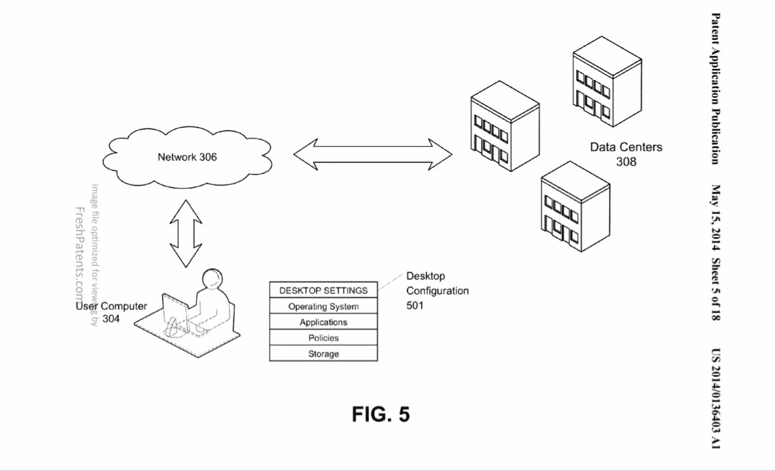.

Works Cited

Das, Manuvir, Sudarshan Yadav, and Arvind Kandhare. "Multi tenancy for single tenancy applications ." (2011). Microsoft. Web. 24 Mar. 2017.

Khanvelkar, Vikas, "Cloud Computing and its effects on the CAD Industry." Web. 24 Mar. 2017.

Dean, Al. "Review: Autodesk Fusion 360." Develop3D, 09 Jan. 2017. Web. 24 Mar. 2017.